Soap UI screen shots for Sprint 4 testing

1. Make sure you JAVA_HOME points to the same JDK version you are using to the run the message receiving application.
2. In the SOAP UI 5.3.0 installation directory, rename the jre to jre_old.
3. Create a SOAP UI project
4. Double click the soap ui – rest project you create and enter the following –

On the keystores tab, click the + sign to add the epic keystore.

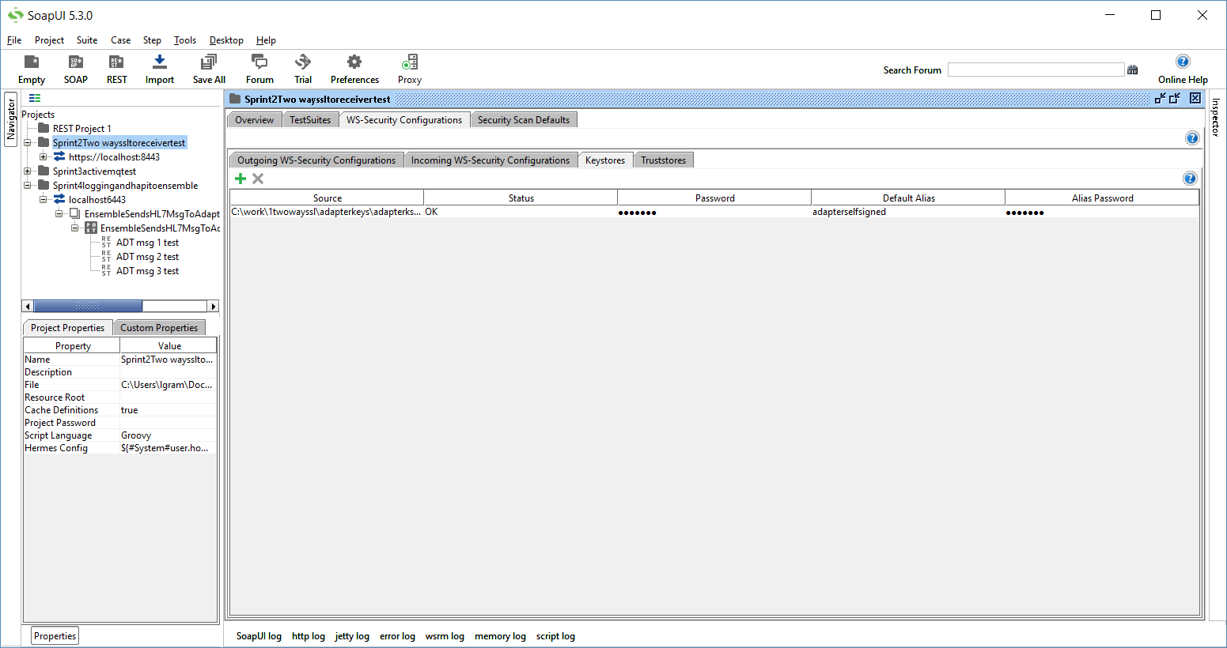

1. Add keystore to preferences

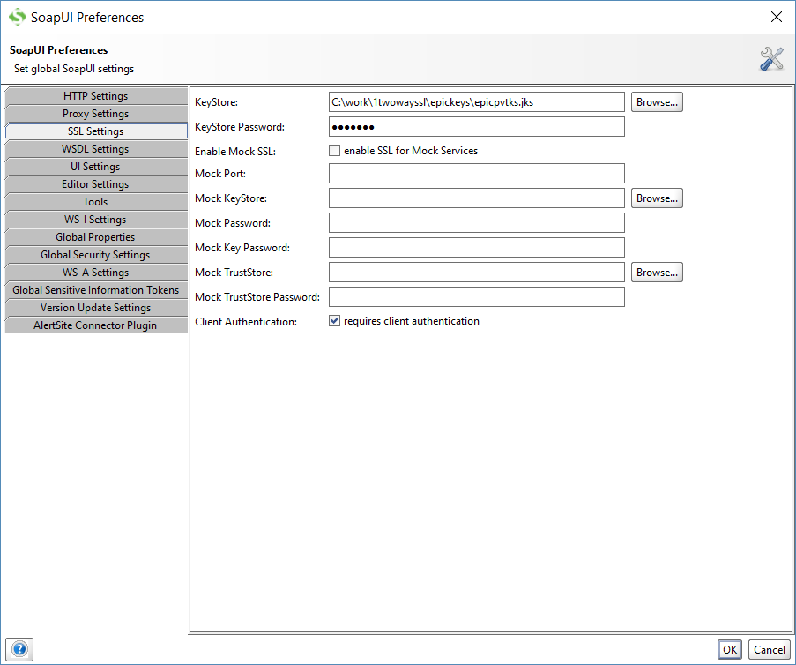

1. Add header content type as shown in left bottom corner

Create a POST request as shown. Test data strings are at the bottom of this doc. Make one request for each HL7 test message.

Hit green arrow to send the request.

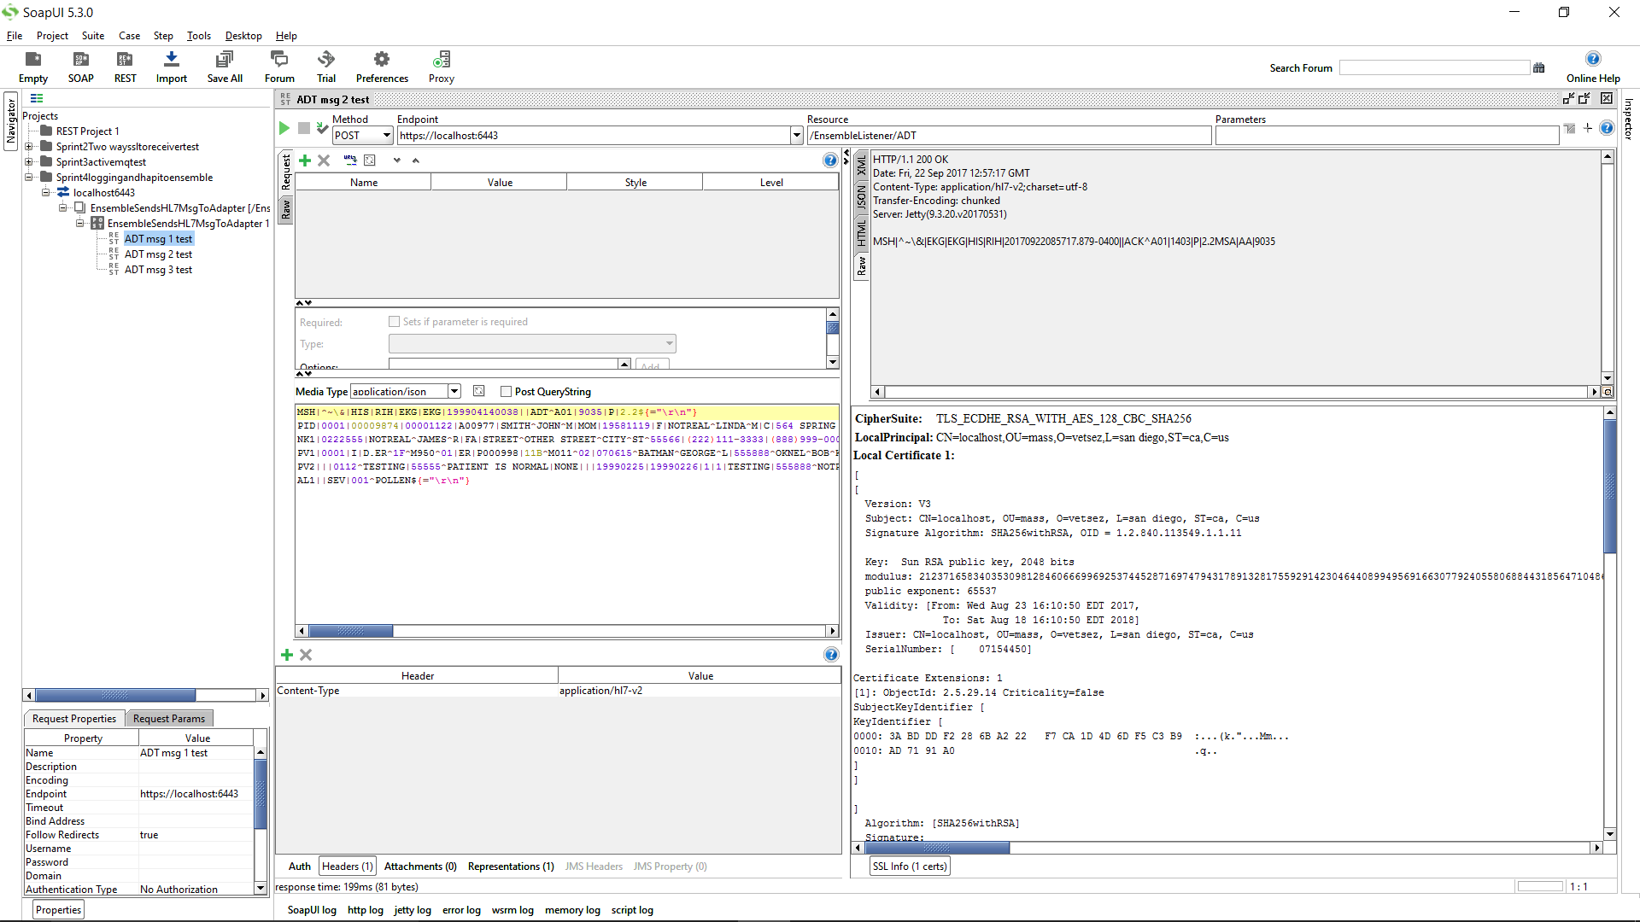

HL7 Message Sample Data strings:

MSH|^~\&|HIS|RIH|EKG|EKG|199904140038||ADT^A01|456|P|2.2${="\r\n"}

MSH|^~\&|ADR||||20170826085937.533-0400||ADT^A01^ADT_A01|2819|T|2.5.1${="\r\n"}

MSH|^~\&|HIS|RIH|EKG|EKG|199904140038||ADT^A01|9035|P|2.2${="\r\n"}

PID|0001|00009874|00001122|A00977|SMITH^JOHN^M|MOM|19581119|F|NOTREAL^LINDA^M|C|564 SPRING ST^^NEEDHAM^MA^02494^US|0002|(818)565-1551|(425)828-3344|E|S|C|0000444444|252-00-4414||||SA|||SA||||NONE|V1|0001|I|D.ER^50A^M110^01|ER|P00055|11B^M011^02|070615^BATMAN^GEORGE^L|555888^NOTREAL^BOB^K^DR^MD|777889^NOTREAL^SAM^T^DR^MD^PHD|ER|D.WT^1A^M010^01|||ER|AMB|02|070615^NOTREAL^BILL^L|ER|000001916994|D||||||||||||||||GDD|WA|NORM|02|O|02|E.IN^02D^M090^01|E.IN^01D^M080^01|199904072124|199904101200|199904101200||||5555112333|||666097^NOTREAL^MANNY^P${="\r\n"}

NK1|0222555|NOTREAL^JAMES^R|FA|STREET^OTHER STREET^CITY^ST^55566|(222)111-3333|(888)999-0000|||||||ORGANIZATION${="\r\n"}

PV1|0001|I|D.ER^1F^M950^01|ER|P000998|11B^M011^02|070615^BATMAN^GEORGE^L|555888^OKNEL^BOB^K^DR^MD|777889^NOTREAL^SAM^T^DR^MD^PHD|ER|D.WT^1A^M010^01|||ER|AMB|02|070615^VOICE^BILL^L|ER|000001916994|D||||||||||||||||GDD|WA|NORM|02|O|02|E.IN^02D^M090^01|E.IN^01D^M080^01|199904072124|199904101200|||||5555112333|||666097^DNOTREAL^MANNY^P${="\r\n"}

PV2|||0112^TESTING|55555^PATIENT IS NORMAL|NONE|||19990225|19990226|1|1|TESTING|555888^NOTREAL^BOB^K^DR^MD||||||||||PROD^003^099|02|ER||NONE|19990225|19990223|19990316|NONE${="\r\n"}

AL1||SEV|001^POLLEN${="\r\n"}